Chapter 4, Problem 69.

Find the maximum power transferred to resistor R in the circuit of Fig. 4.135.

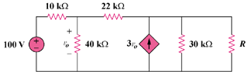

0.003v_{o}

Figure 4.135
For Prob. 4.69.

